**Problem-01:**

Consider the network shown in the figure.

|  |  |  |  |  |  |  |  |
| --- | --- | --- | --- | --- | --- | --- | --- |
|  |  | 1 |  |  |  |  |  |
| 3 | C | 1 | 3 | E |  |  |  |
|  |  |  |  |  |
|  |  | A |  | 1 |  | 6 | G |
| B |  | 2 |  |  |  |  |
| D |  |  |  |  |  |
| 2 |  |  |  | F |  | 2 |
|  |  |  |  |  |
|  |  | 1 |  |  |  |  |
|  |  |  |  |  |  |  |

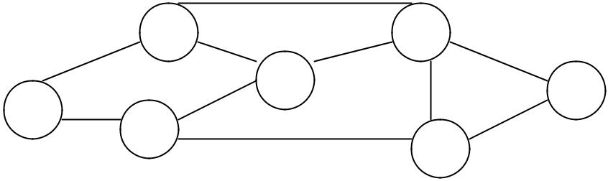

Using distance vector routing:

a) Show the data that node A will receive on the first iteration of the algorithm.

b) Show the routing table for node A after the first iteration of the algorithm has been completed.

**Problem-02:**

Consider a network with five nodes, N1 to N5, as shown below

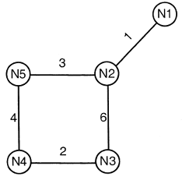

The network uses a Distance Vector Routing Protocol. Once the Route has converged, write down the distance vectors at different nodes. If the cost of link N2-N3 reduces to 2 (in both directions). After the next round updates, what will be the new distance vector at node, N3?

**Problem-03:**

For the IP address of 130.124.38.65 /20 answer the following:

1. Subnet Mask (SNM)
2. Subnet address
3. No. of Subnets
4. No. of Hosts
5. Broadcast Address

**Problem-04:**

Consider the following network:

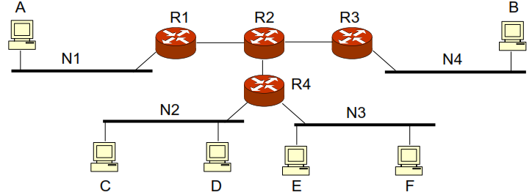

As a network administrator you are assigned with the task of creating four different subnets of equal size for networks N1, N2, N3 and N4. Divide 196.0.0.0 address space in such a way so that this requirement is met.

(a) Write down the addresses that are used to uniquely identify the four different networks.

(b) Write down appropriate IP addresses for the following hosts: A, B, C, D, E and F.

(c) Write down the default gateway for networks N1, N2, N3 and N4.

(d) Write down the subnet mask for each of the four networks.

**Problem-05:**

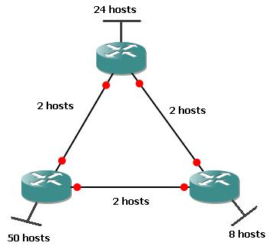

Create the addressing scheme for the IP: 192.168.10.0 by using the concept of VLSM and CIDR.